|  |  |  |  |
| --- | --- | --- | --- |
|  | Bansilal Ramnath Agarwal Charitable Trust's  Vishwakarma Institute of Information Technology  **Department of**  **Artiﬁcial Intelligence and Data Science** | | |
| Student Name: **Siddhesh Dilip Khairnar** | | | |
| Class: **SY** | Division: **B** | | Roll No: **272028** |
| Semester: **4** | | Academic Year: **2022-23** | |
| Subject Name & Code: **Fundamentals of Computer Networks, ADUA22203** | | | |
| Title of Assignment: **ASSIGNMENT NO.9: Write a program to demonstrate subnetting and ﬁnd the subnet masks.** | | | |
| Date of Performance: **15-04-23** | | Date of Submission: **24-04-23** | |

# ------------------------------------------------------------

**Aim: Write a program to demonstrate subletting and ﬁnd the subnet masks.**

**Software Requirement: VS CODE**

# -----------------------------------------------------------

**Result of Experimentation:**

import java.io.*;

import java.net.InetAddress; public class assign5 {

public static void main(String[] args) throws IOException {

System.out.println("ENTER IP:"); BufferedReader br = new BufferedReader(new

InputStreamReader(System.in)); String ip = br.readLine();

String checkclass = ip.substring(0, 3); int cc = Integer.parseInt(checkclass); String mask = null;

if(cc>0)

{

if(cc<=127)

{

mask = "255.0.0.0";

System.out.println("Class A IP Address"); System.out.println("SUBNET MASK:\n"+mask);

}

if(cc>=128 && cc<=191)

{

mask = "255.255.0.0";

System.out.println("Class B IP Address");

System.out.println("SUBNET MASK:\n"+mask);

if(cc>=192 && cc<=223)

mask = "255.255.255.0";

System.out.println("Class C IP Address"); System.out.println("SUBNET MASK:\n"+mask);

if(cc>=224 && cc<=239)

mask = "255.0.0.0";

System.out.println("Class D IP Address Used for

multicasting");

if(cc>=240 && cc<=254)

mask = "255.0.0.0";

System.out.println("Class E IP Address Experimental Use");

String networkAddr="";

String lastAddr="";

String[] ipAddrParts=ip.split("\\."); String[] maskParts=mask.split("\\."); for(int i=0;i<4;i++){

int x=Integer.parseInt(ipAddrParts[i]);

int y=Integer.parseInt(maskParts[i]);

networkAddr+=z+"."; int w=z|(y^255);

int z=x&y;

lastAddr+=w+".";

System.out.println("First IP of block: "+networkAddr);

System.out.println("Last IP of block: "+lastAddr);

}

**Output:**

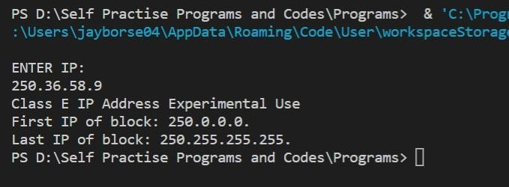

# ------------------------------------------------------------

**Conclusion:**

Thus, we have manually taken input of IP Address from the user. Our program shows us the Class, First and Last IP Block. Also, it checks if the IP address is in the given range. Hence, we have successfully implemented the subnetting and subnet mask program.